River Basic Scenario Analysis
River Legislation Analysis
By: Ignasi Gómez-Sebastià

River Legislation Analysis

Description of Work Task Description
Analysis of different high level river legislations

Legislation summary: European91/271/EEC
Urban Waste Water Directive Overview.
http://ec.europa.eu/environment/water/water-urbanwaste/index_en.html
Article 2: Set of ontological concepts and classification rules (not counts-as as they are not institutional)
Article 4: Norm: Obligation. Possible counts-as (Discharge, agglomeration, fresh water, stuary) Changes over time (even agglomeration counts-as). Exception (counts-as high mountain region, counts-as heavy rain).
Article 5: Ontological classification (sensitive area)
Article 6: Norm + Norm spirit!
Article 9: Inter-state issues
Article 13: norm
Article 14: re-use and appropriate treatme of sludge. Prohibition of dumping sludge to surface waters. Until then, progressively reduce sludge (norm trend analysis)
Article 15: Shall monitor.
Annex I.B: obligation to have sensor at the entrance and exit of WWTP
Annex I.D: Sensor characteristics, and exceptions (heavy rain)
Table 1: WW parameters which are accepted and expected reduction.
Table 2: Like table 1 for sensitive areas (change: make an area sensitive)
Annex II: Definition of sensitive and less sensitive areas (ontology?)
Annex III: Industrial sectors

96/61/EC
Integrated Pollution Prevention and Control (IPPC)
http://eur-lex.europa.eu/LexUriServ/LexUriServ.do?uri=CELEX:31996L0061:en:PDF
Article 3: Efficient energy use
Articles 4 and 5: Licenses grant to new and existing industries
Article 12: No changes in industry operation without notifying authority
Article 13: Force update on operation permit (high pollution caused by industry, best available techniques improve, operational safety, new legislation forces update).
Article 14: Operator informs about relases and about incidents.
Article 17: Inter-state pollution + Strange see to it
Annex I : More industry clarifications
Annex II : directives for more pollutants (worth exploring?)
Annex III : Pollutants to set limits for (Ontology)

2000/60/EC
The EU Water Framework Directive - integrated river basin management for Europe
http://eur-lex.europa.eu/resource.html?uri=cellar:5c835afb-2ec6-4577-bdf8-756d3d694eeb.0004.02/DOC_1&format=PDF
Set of ontological terms (e.g., good ground water)
3.3. International river basin
4b.III: Reverse any significantly and sustained upward trend in the concentration of any pollutant (ground water). Dynamic norm
4.6: Temporal deterioration in bodies of water is allowed on floods, droughts or accidents that can not be foreseen. Then, further deterioration in water status should be prevented.
7 Identify water used for drinking (or to be used in the future) and minimize deterioration to minimize purification treatments required to make water drinking water.
8 Water monitoring: Including volume, flow and chemical status
9 Water pricing policies (disaggregated in industry, household and agriculture)
10 References to 96/61/EC (see above) 91/271/EC (see above) and 91/676/EEC (protection of waters against pollution from nitrates in agricultural sources)
11 : Set of measures to be adopted by state members (high level point of view).
11.3.g: Prohibition or registration and notification of pollutants going into the water (Dynamic norm!)
11.j : Don’t mix wastewater from mines/quarries with other sources.
11.l: Reduce pollution spills from technical installations due to unforeseen events (floods). Detect and send warning of such events including accidents.
13: river basin management plans
16 + 17 : strategies to prevent pollution of water and groundwater, centered on prioritizing pollutant concentrations.
22: Repeals and transitional provisions (for dynamic norms)
23: Members have the obligation to provide effective penalties
Annex II: Water body classification and types (look just to tables for Ontology)
Annex III : Requirements of economic analysis
Annex V: Classifications and normative definitions (1.2) Includes colour codes
Annex XI (last page): Euroregions

80/68/EEC
http://eur-lex.europa.eu/legal-content/EN/TXT/PDF/?uri=CELEX:31980L0068&from=en
Glosary of ontological terms on Annex I

Legislation summary: National

(76/464/EEC) RD/995/2000
Available in XML format
Wastewater emission limits related to European Decree
Disposal of Type I (annex I) limit
Disposal of Type II (annex II) reduce (look at plans for each basin)

(2006/11/EEC) RD/258/89
Derogation of former directives to apply new
Two normative frameworks in place at the same time
Stablish NCA (Normas de Calidad Ambiental) levels for:
- Sustancias prioritarias y otros contaminantes de riesgo en el ámbito europeo
- Sustancias preferentes de riesgo en el ámbito estatal
- Procedimientos para el cálculo de las NCA
- Zonas de mezcla donde se pueden superar las NCA
Cap IV: Inventario de emisiones, salidas y pérdidas(salida del simulador)
Cap V: No se incumplen normas en caso de contaminación trans-fronteriza
Disposición derogativa primera y disposición derogativa segunda (pag. 682)
Anexo I: sustancias prioritarias
Anexo II: Sustancias preferentes
Anexo III: Relación de sustancias contaminantes

(917271/EEC + 98/15/EEC) RD 11/95
Tratamiento de aguas residuales en aglomeraciones urbanas. Deriva a leyes autonómicas.

(80/778/EEC + 98/83/EEC) RD 140/03
Referente a aguas para consumo humano. ¿Posible ampliación del simulador con potabilizadoras en ciudades o industrias (e.g., cervezas duff)?
Conceptos ontológicos + tabla con límites legales

(2006/7/EC) RD/734/88
Referente a aguas para baño. Poco probable ampliación del simulador. Normativa no demasiado específica.

(79/923/EEC) RD 345/1993
Agua para granajas (e.g., moluscos). Poco probable ampliación del simulador.
Conceptos ontológicos + tabla con límites legales

(89/659/EEC) Order 16/11/88 + RD 927/88 (Annex II)
Calidad exigida a las aguas dulces superficiales para ser aptas para el baño
http://noticias.juridicas.com/base_datos/Admin/rd927-1988.anexo2.html#anexo1anexo2

RD/1664/1998
REAL DECRETO 1664/1998, de 24 de julio, por el que se aprueban los Planes Hidrológicos de cuenca.
Parámetros aplicables a las mediciones (elementos ontológicos) y derogaciones (buscar datos originales?) en base a (2006/11/EEC) RD/258/89

Legislation summary: Regional

(91/271/EEC) Catalan Sanitation Plan
Contains mainly 2 interesting elements:
Urban Wastewater Treatment Program
Industrial Wastewater Treatment Program
PSARU 2002
PSARI 2003
Updated due to (2000/60/EC) in PSARU 2005
Links both Urban and Industrial Wastewater Treatment Programs
http://aca-web.gencat.cat/aca/appmanager/aca/aca?_nfpb=true&_pageLabel=P1204654461208200526170&profileLocale=es#fragment-3
Análisis económico de la implantación del plan nacional (Español)
Adaptación de límites para tratamiento de aguas en alta montaña.
Objetivos de tratamiento y limites por Cuenca.

Decret legislatiu 3/2003
http://www20.gencat.cat/portal/site/portaljuridic/menuitem.d15a4e5dfb99396dc366ec10b0c0e1a0/?action=fitxa&documentId=312716

Decret 380/2006

Acord govern 238/2010
http://legislacion.derecho.com/acord-gov-238-2010-23-noviembre-2010-departament-de-medi-ambient-i-habitatge-3102281

Resolució MAH/2370/2006
http://legislacion.derecho.com/resolucio-mah-2370-2006-03-julio-2006-departament-de-medi-ambient-i-habitatge-145160

Resolucio MAB/2964/2003
http://aca-web.gencat.cat/aca/documents/ca/legislacio/resolucio/resoldogc_mab_2964_2003.pdf

91/271/EEC
This directive concerns the collection, treatment and discharge of urban wastewater and the treatment and discharge of wastewater from industrial sectors. The objective is to protect the environment from the effects of these discharges

Article 2
Set of ontological terms to be used in the normative system:
'urban waste water' means domestic waste water or the mixture of domestic waste water with industrial waste water and/or run-off rain water
'domestic waste water' means waste water from residential settlements and services which originates predominantly from the human metabolism and from household activities
'industrial waste water' means any waste water which is discharged from premises used for carrying on any trade or industry, other than domestic waste water and run-off rain water
'agglomeration' means an area where the population and/or economic activities are sufficiently concentrated for urban waste water to be collected and conducted to an urban waste water treatment plant or to a final discharge point.
'collecting system' means a system of conduits which collects and conducts urban waste water.
p.e. (population equivalent) means the organic biodegradable load having a five-day biochemical oxygen demand (BOD5) of 60 g of oxygen per day.
'primary treatment' means treatment of urban waste water by a physical and/or chemical process involving settlement of suspended solids, or other processes in which the BOD5 of the incoming waste water is reduced by at least 20 % before discharge and the total suspended solids of the incoming waste water are reduced by at least 50 %.
'secondary treatment' means treatment of urban waste water by a process generally involving biological treatment with a secondary settlement or other process in which the requirements established in Table 1 of Annex I are respected.
'appropriate treatment' means treatment of urban waste water by any process and/or disposal system which after discharge allows the receiving waters to meet the relevant quality objectives and the relevant provisions of this and other Community Directives.
'Sludge' means residual sludge, whether treated or untreated, from urban waste water treatment plants.
'eutrophication' means the enrichment of water by nutrients, especially compounds of nitrogen and/or phosphorus, causing an accelerated growth of algae and higher forms of plant life to produce an undesirable disturbance to the balance of organisms present in the water and to the quality of the water concerned.
'estuary' means the transitional area at the mouth of a river between fresh-water and coastal waters. Member States shall establish the outer (seaward) limits of estuaries for the purposes of this Directive as part of the programme for implementation in accordance with the provisions of Article 17 (1) and (2).
17.1 Member States shall by 31 December 1993 establish a programme for the implementation of this Directive.
17.2. Member States shall by 30 June 1994 provide the Commission with information on the programme.
'coastal waters' means the waters outside the low water line or the outer limit of an estuary.

Article 3
Collecting systems should satisfy requirements on annex I on:
- At least by December 31 2000 for those with a p.e. of more than 15.000
- At least by December 31 2005 for those with a p.e. between 2.000 and 15.000

Article 4
1. Member states shall ensure that urban waste water entering collecting systems shall before discharge be subject to secondary treatment or an equivalent treatment as follows :
— at the latest by 31 December 2000 for all discharges from agglomerations of more than 15 000 p.e.,
— at the latest by 31 December 2005 for all discharges from agglomerations of between 10 000 and 15 000 p.e.,
— at the latest by 31 December 2005 for discharges to fresh-water and estuaries from agglomerations of between 2 000 and 10 000 p.e.
2. Urban waste water discharges to waters situated in high mountain regions (over 1 500 m above sea level) where it is difficult to apply an effective biological treatment due to low temperatures may be subjected to treatment less stringent than that prescribed in paragraph 1, provided that detailed studies indicate that such discharges do not adversely affect the environment.
From psaru_2005-2010.pdf - >page 31662
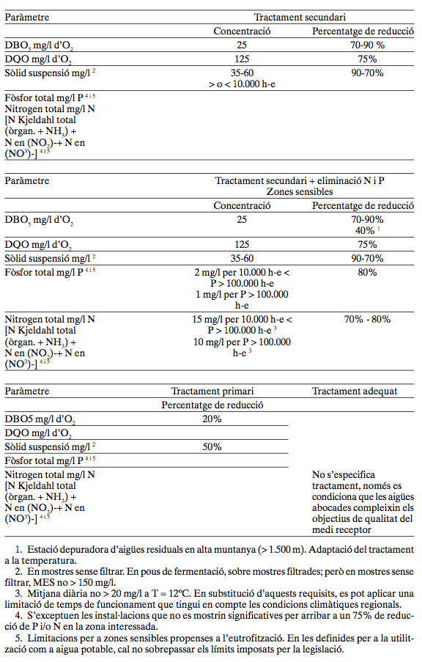
3. Discharges from urban waste water treatment plants described in paragraphs 1 and 2 shall satisfy the relevant requirements of Annex I.B. These requirements may be amended in accordance with the procedure laid down in Article 18.
4. The load expressed in p.e. shall be calculated on the basis of the maximum average weekly load entering the treatment plant during the year, excluding unusual situations such as those due to heavy rain.

Article 5
1. For the purposes of paragraph 2, Member States shall by 31 December 1993 identify sensitive areas according to the criteria laid down in Annex II.
2. Member States shall ensure that urban waste water entering collecting systems shall before discharge into sensitive areas be subject to more stringent treatment than that described in Article 4, by 31 December 1998 at the latest for all discharges from agglomerations of more than 10 000 p.e.
3. Discharges from urban waste water treatment plants described in paragraph 2 shall satisfy the relevant requirements of Annex I B. These requirements may be amended in accordance with the procedure laid down in Article 18.
4. Alternatively, requirements for individual plants set out in paragraphs 2 and 3 above need not apply in sensitive areas where it can be shown that the minimum percentage of reduction of the overall load entering all urban waste water treatment plants in that area is at least 75 % for total phosphorus and at least 75 % for total nitrogen .
5. Discharges from urban waste water treatment plants which are situated in the relevant catchment areas of sensitive areas and which contribute to the pollution of these areas shall be subject to paragraphs 2, 3 and 4.
In cases where the above catchment areas are situated wholly or partly in another Member State Article 9 shall apply.
6. Member States shall ensure that the identification of sensitive areas is reviewed at intervals of no more than four years.

Article 6

1. For the purpose of paragraph 2, member states may by 31 December 1993 identify less sensitive areas according to the criteria laid down in Annex II.
2. Urban waste water discharges from agglomerations of between 10 000 and 150 000 p.e. to coastal waters and those from agglomaterions of between 2 000 and 10 000 p.e. to estuaries situated in areas described in paragraph 1 may be subjected to treatment less stringent than that prescribed in Article 4 providing that :
— such discharges receive at least primary treatment as defined in Article 2 (7) in conformity with the control procedures laid down in Annex I D,
Found list of sensitive áreas
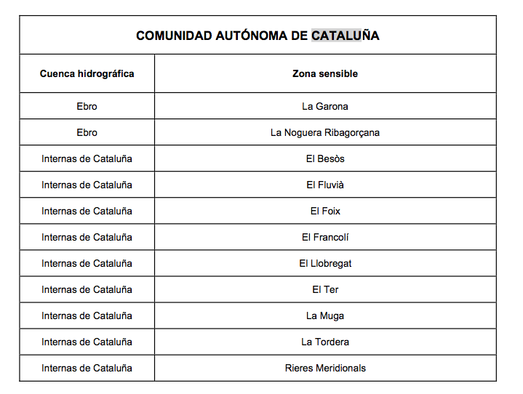
— comprehensive studies indicate that such discharges will not adversely affect the environment.
Member States shall provide the Commission with all relevant information concerning the abovementioned studies .
3. If the Commission considers that the conditions set out in paragraph 2 are not met, it shall submit to the Council an appropriate proposal.
4. Member States shall ensure that the identification of less sensitive areas is reviewed at intervals of not more than four years.
5. Member States shall ensure that areas no longer identified, as less sensitive shall within seven years meet the requirements of Articles 4 and 5 as appropriate.

Article 7
Member States shall ensure that, by 31 December 2005, urban waste water entering collecting systems shall before discharge be subject to appropriate treatment as defined in Article 2 (9) in the following cases :
— for discharges to fresh-water and estuaries from agglo merations of less than 2 000 p.e.,
— for discharges to coastal waters from agglomerations of less than 10 000 p.e.

Article 8
1. . Member States may, in exceptional cases due to technical problems and for geographically defined popu lation groups, submit a special request to the Commission for a longer period for complying with Article 4.
5. In exceptional circumstances, when it can be demonstrated that more advanced treatment will not
produce any environmental benefits, discharges into less sensitive areas of waste waters from agglomerations of more than 1 50 000 p.e. may be subject to the treatment provided for in Article 6 for waste water from agglomera tions of between 10 000 and 150 000 p.e.

Article 9
Where waters within the area of jurisdiction of a Member State are adversely affected by discharges of urban waste water from another Member State, the Member State whose waters are affected may notify the other Member State and the Commission of the relevant facts.
The Member States concerned shall organize, where appropriate with the Commission, the concentration necessary to identify the discharges in question and the measures to be taken at source to protect the waters that are affected in order to ensure conformity with the provisions of this Directive.

Article 11
1. Member States shall ensure that, before 31 December 1993, the discharge of industrial waste water into collecting systems and urban waste water treatment plants is subject to prior regulations and/or specific authorizations by the competent authority or appropriate body.
2. Regulations and/ or specific authorization shall satisfy the requirements of Annex I C. These requirements may be amended in accordance with the procedure laid down in Article 18 .
3. Regulations and specific authorization shall be reviewed and if necessary adapted at regular intervals.
FROM PSARI 2003 psari2003.pdf Section 4,5,2
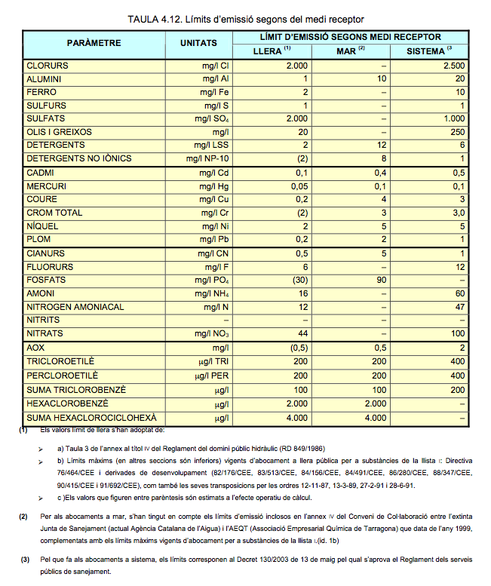

Article 12
1. Treated waste water shall be reused whenever appropriate. Disposal routes shall minimize the adverse effects on the environment.
2. Competent authorities or appropriate bodies shall ensure that the disposal of waste water from urban waste water treatment plants is subject to prior regulations and/or specific authorization.
3. Prior regulations and/or specific authorization of discharges from urban waste water treatment plants made pursuant to paragraph 2 within agglomerations of 2 000 to 10 000 p.e. in the case of discharges to fresh waters and estuaries, and of 10 000 p.e. or more in respect of all discharges, shall contain conditions to satisfy the relevant requirements of Annex I B. These requirements may be amended in accordance with the procedure laid down in Article 18.
4. Regulations and/or authorization shall be reviewed and if necessary adapted at regular intervals.

Article 13

1. Member States shall ensure that by 31 December 2000 biodegradable industrial waste water from plants belonging to the industrial sectors listed in Annex III which does not enter urban waste water treatment plants before discharge to receiving waters shall before discharge respect conditions established in prior regulations and/or specific authorization by the competent authority or appropriate body, in respect of all discharges from plants representing 4 000 p.e. or more.
2. By 31 December 1993 the competent authority or appropriate body in each Member State shall set require ments appropriate to the nature of the industry concerned for the discharge of such waste water.
3. The Commission shall carry out a comparison of the Member States' requirements by 31 December 1994. It shall publish the results in a report and if necessary make an appropriate proposal.

Article 14
1. Sludge arising from waste water treatment shall be re-used whenever appropriate. Disposal routes shall mini mize the adverse effects on the environment.
2. Competent authorities or appropriate bodies shall ensure that before 31 December 1998 the disposal of sludge from urban waste water treatment plants is subject to general rules or registration or authorization.
From 03_manual_directiva_91_271_cee_tcm7-28959.pdf
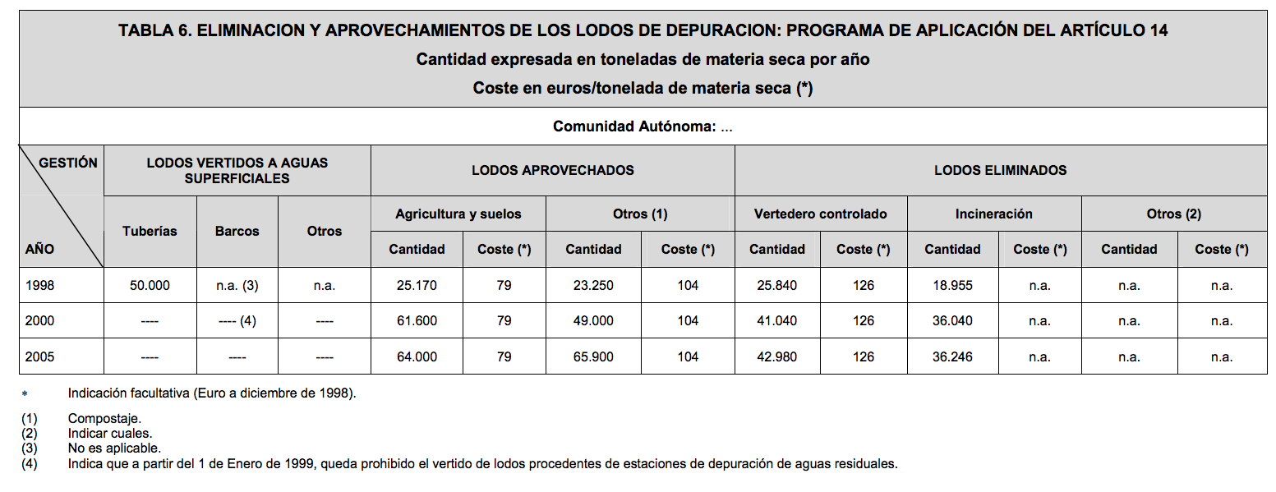
3. Member States shall ensure that by 31 December 1998 the disposal of sludge to surface waters by dumping from ships, by discharge from pipelines or by other means is phased out.
4. Until the elimination of the forms of disposal mentioned in paragraph 3, Member States shall ensure that the total amount of toxic, persistent or bioaccumulable materials in sludge disposed of to surface waters is licensed for disposal and progressively reduced.

Article 15
1. Competent authorities or appropriate bodies shall monitor :
— discharges from urban waste water treatment plants to verify compliance with the requirements of Annex I.B in accordance with the control procedures laid down in Annex I.D,
— amounts and composition of sludges disposed of to surface waters.
2. Competent authorities or appropriate bodies shall monitor waters subject to discharges from urban waste water treatment plants and direct discharges as described in Article 13 in cases where it can be expected that the receiving environment will be significantly affected.
3. In the case of a discharge subject to the provisions of Article 6 and in the case of disposal of sludge to surface waters, Member States shall monitor and carry out any other relevant studies to verify that the discharge or disposal does not adversely affect the environment.
4. Information collected by competent authorities or appropriate bodies in complying with paragraphs 1, 2 and 3 shall be retained in the Member State and made available to the Commission within six months of receipt of a request.
5. Guidelines on the monitoring referred to in paragraphs 1, 2 and 3 may be formulated in accordance with the procedure laid down in Article 18.

Annex I
Collecting systems
Collecting systems shall take into account waste water treatment requirements.
The design, construction and maintenance of collecting systems shall be undertaken in accordance with the best technical knowledge not entailing excessive costs, notably regarding:
— volume and characteristics of urban waste water,
— prevention of leaks,
— limitation of pollution of receiving waters due to storm water overflows.
Discharge from urban waste water treatment plants to receiving waters (Error: Reference source not found)
1. Waste water treatment plants shall be designed or modified so that representative samples of the incoming waste water and of treated effluent can be obtained before discharge to receiving waters.
2. Discharges from urban waste water treatment plants subject to treatment in accordance with Articles 4 and 5 shall meet the requirements shown in Table 1.
3. Discharges from urban waste water treatment plants to those sensitive areas which are subject to eutrophication as identified in Annex IIA (a) shall in addition meet the requirements shown in Table 2 of this Annex.
4. More stringent requirements than those shown in Table 1 and/or Table 2 shall be applied where required to ensure that the receiving waters satisfy any other relevant Directives.
See BOE-A-2011-1139.pdf (Annex I and Annex II)
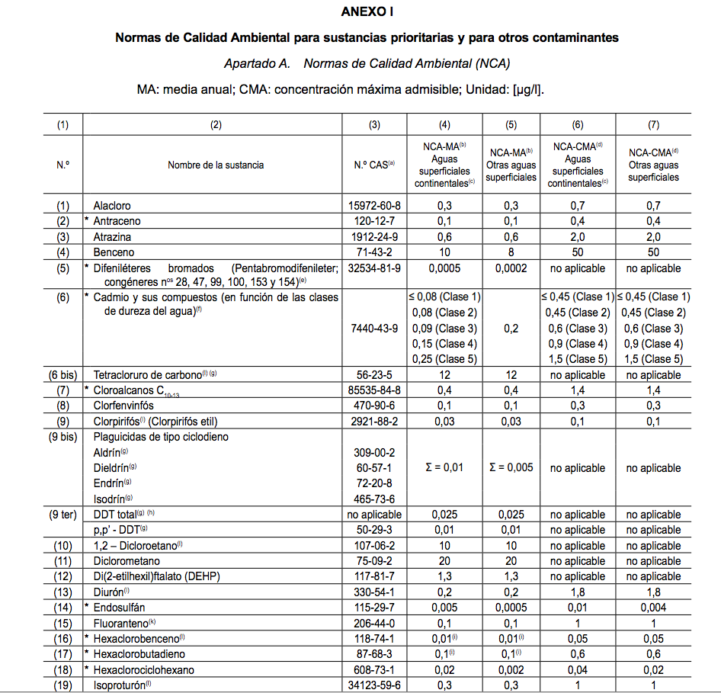
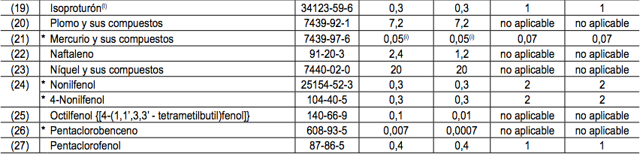
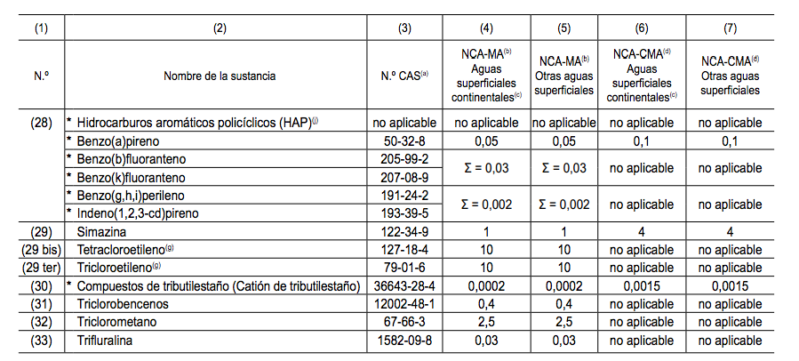
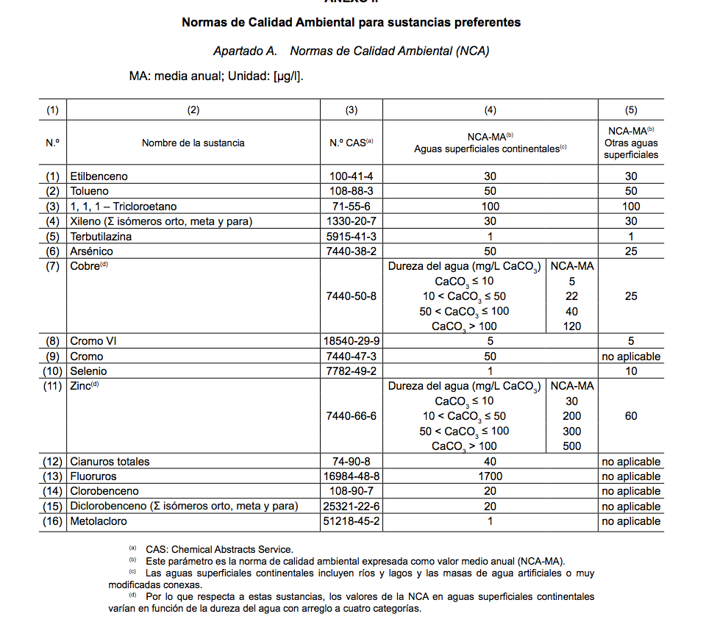
5. The points of discharge of urban waste water shall be chosen, as far as possible, so as to minimize the effects on receiving waters.
Industrial waste water
Industrial waste water entering collecting systems and urban waste water treatment plants shall be subject to such pre-treatment as is required in order to :
— protect the health of staff working in collecting systems and treatment plants,
— ensure that collecting systems, waste water treatment plants and associated equipment are not damaged,
— ensure that the operation of the waste water treatment plant and the treatment of sludge are not impeded,
— ensure that discharges from the treatment plants do not adversely affect the environment, or prevent receiving water from complying with other Community Directives,
— ensure that sludge can be disposed of safety in an environmentally acceptable manner.

Reference methods for monitoring and evaluation of results
1. Member States shall ensure that a monitoring method is applied which corresponds at least with the level of requirements described below.
Alternative methods to those mentioned in paragraphs 2; 3 and 4 may be used provided that it can be demonstrated that equivalent results are obtained.
Member States shall provide the Commission with all relevant information concerning the applied method. If the Commission considers that the conditions set out in paragraphs 2, 3 and 4 are not met, it will submit an appropriate proposal to the Council.
2. Flow-proportional or time-based 24-hour samples shall be collected at the same well-defined point in the outlet and if necessary in the inlet of the treatment plant in order to monitor compliance with the requirements for discharged waste water laid down in this Directive.
Good international laboratory practices aiming at minimizing the degradation of samples between collection and analysis shall be applied.
3. The minimum annual number of samples shall be determined according to the size of the treatment plant and be collected at regular intervals during the year :
— 2 000 to 9 999 p. e. : 12 samples during the first year.
Four samples in subsequent years, if it can be shown that the water during the first year complies with the provisions of the Directive ; if one sample of the four fails, 12 samples must be taken in the year that follows.
— 10000 to 49999 p.e.: — 50 000 p. e. or over : 12 samples. 24 samples.
4. The treated waste water shall be assumed to conform to the relevant parameters if, for each relevant parameter considered individually, samples of the water show that it complies with the relevant parametric value in the following way :
(a) for the parameters specified in Table 1 and Article 2 (7), -primary treatment- a maximum number of samples which are allowed to fail the requirements, expressed in concentrations and/or percentage reductions in Table 1 and Article 2 (7), is specified in Table 3 ;
(b) for the parameters of Table 1 expressed in concentrations, the failing samples taken under normal operating conditions must not deviate from the parametric values by more than 100 %. For the parametric values in concentration relating to total suspended solids deviations of up to 150 % may be accepted
(c) for those parameters specified in Table 2 the annual mean of the samples for each parameter shall conform to the relevant parametric values.
5. Extreme values for the water quality in question shall not be taken into consideration when they are the result of unusual situations such as those due to heavy rain.
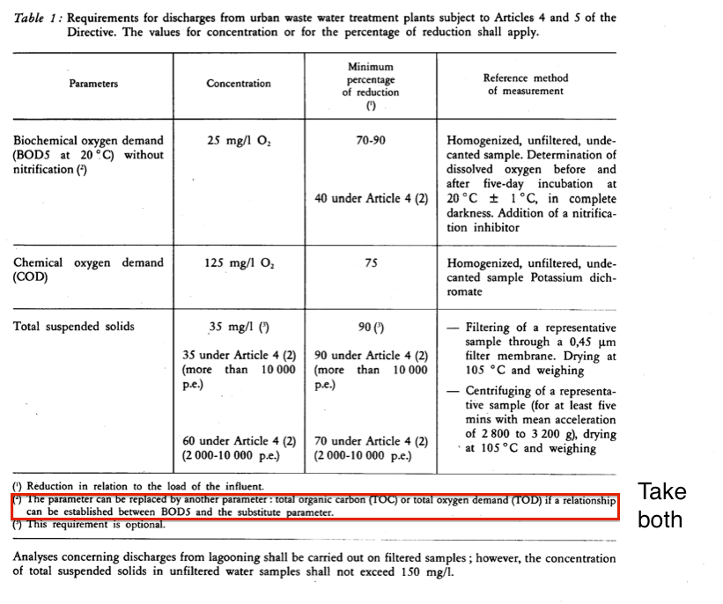
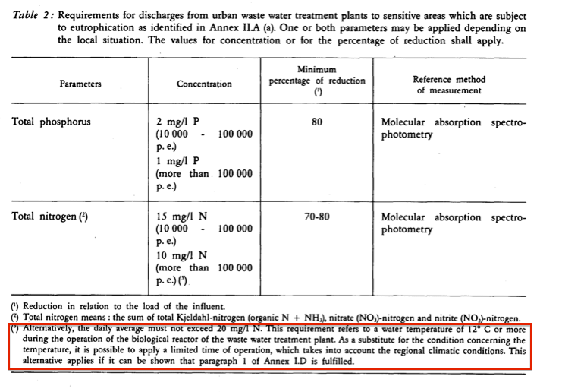
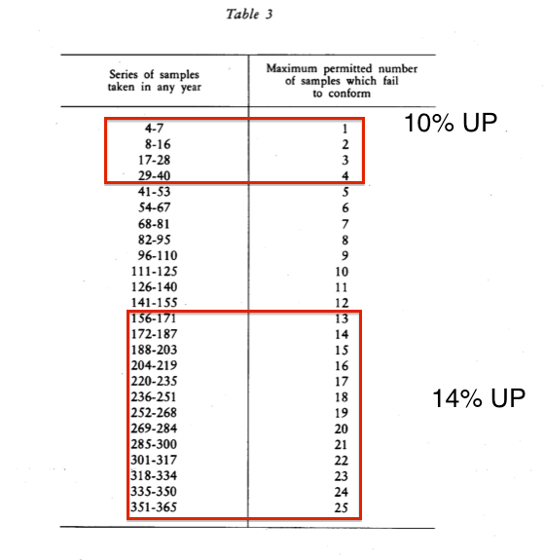

Annex 2
A. Sensitive areas
A water body must be identified as a sensitive area if it falls into one of the following groups :
(a) natural freshwater lakes, other freshwater bodies, estuaries and coastal waters which are found to be eutrophic or which in the near future may become eutrophic if protective action is not taken.
The following elements might be taken into account when considering which nutrient should be reduced by further treatment :
(i) lakes and streams reaching lakes/reservoirs/closed bays which are found to have a poor water exchange, whereby accumulation may take place. In these areas, the removal of phosphorus should be included unless it can be demonstrated that the removal will have no effect on the level of
eutrophication. Where discharges from large agglomerations are made, the removal of nitrogen may also be considered ;
(ii) estuaries, bays and other coastal waters which are found to have a poor water exchange, or which receive large quantities of nutrients. Discharges from small agglomerations are usually of minor importance in those areas, but for large agglomerations, the removal of phosphorus and/or nitrogen should be included unless it can be demonstrated that the removal will have no effect on the level of eutrophication ;
(b) surface freshwaters intended for the abstraction of drinking water which could contain more than the concentration of nitrate laid down under the relevant provisions of Council Directive 75/440/EEC of 16 June 1975 concerning the quality required of surface water intended for the abstraction of drinking water in the Member States (') if action is not taken ;
(c) areas where further treatment than that prescribed in Article 4 of this Directive is necessary to fulfil Council Directives.
B. Less sensitive areas
A marine water body or area can be identified as a less sensitive area if the discharge of waste water does not adversely affect the environment as a result of morphology, hydrology or specific hydraulic conditions which exist in that area.
When identifying less sensitive areas, Member States shall take into account the risk that the discharged load may be transferred to adjacent areas where it can cause detrimental environmental effects. Member States shall recognize the presence of sensitive areas outside their national jurisdiction.
The following elements shall be taken into consideration when identifying less sensitive areas :
open bays, estuaries and other coastal waters with a good water exchange and not subject to eutrophication or oxygen depletion or which are considered unlikely to become eutrophic or to develop oxygen depletion due to the discharge of urban waste water.

Annex 3
1. Milk-processing
2. Manufacture of fruit and vegetable products
3. Manufacture and bottling of soft drinks
4. Potato-processing
5. Meat industry
6. Breweries
7. Production of alcohol and alcoholic beverages
8. Manufacture of animal feed from plant products
9. Manufacture of gelatine and of glue from hides, skin and bones
10. Malt-houses
11. Fish-processing industry

96/61/EC
The purpose of this Directive is to achieve integrated prevention and control of pollution arising from the activities listed in Annex I. It lays down measures designed to prevent or, where that is not practicable, to reduce emissions in the air, water and land from the abovementioned activities, including measures concerning waste, in order to achieve a high level of protection of the environment taken as a whole , without prejudice to Directive 85/337/EEC and other relevant Community provisions.

Article 2
1. 'substance' shall mean any chemical element and its compounds, with the exception of radioactive substances within the meaning of Directive 80/836/ Euratom (') and genetically modified organisms within the meaning of Directive 90/219/EEC (2) and Directive 90/220/EEC(3);
2. 'pollution shall mean the direct or indirect introduction as a result of human activity, of substances, vibrations, heat or noise into the air, water or land which may be harmful to human health or the quality of the environment, result in damage to mate rial property, or impair or interfere with amenities and other legitimate uses of the environment;
3. 'installation shall mean a stationary technical unit where one or more activities listed in Annex I are carried out, and any other directly associated activities which have a technical connection with the activities carried out on that site and which could have an effect on emissions and pollution;
4. 'existing installation’ shall mean an installation in operation or, in accordance with legislation existing before the date on which this Directive is brought into effect, an installation authorized or in the view of the competent authority the subject of a full request for authorization, provided that that installation is put into operation no later than one year after the date on which this Directive is brought into effect;
5. 'emission’ shall mean the direct or indirect release of substances, vibrations, heat or noise from individual or diffuse sources in the installation into the air, water or land;
6. 'emission limit values’ shall mean the mass, expressed in terms of certain specific parameters, concentration and / or level of an emission , which may not be exceeded during one or more periods of time. Emission limit values may also be laid down for certain groups, families or categories of substances, in particular for those listed in Annex III.
The emission limit values for substances shall normally apply at the point where the emissions leave the installation, any dilution being disregarded when determining them. With regard to indirect releases into water, the effect of a water treatment plant may be taken into account when determining the emission limit values of the installation involved, provided that an equivalent level is guaranteed for the protection of the environment as a whole and provided this does not lead to higher levels of pollution in the environment, without prejudice to Directive 76/464/EEC or the Directives implementing it;
7. 'environmental quality standard' shall mean the set of requirements which must be fulfilled at a given time by a given environment or particular part thereof, as set out in Community legislation;
8. 'competent authority shall mean the authority or authorities or bodies responsible under the legal provisions of the Member States for carrying out the obligations arising from this Directive;
9. 'permit' shall mean that part or the whole of a written decision (or several such decisions) granting authorization to operate all or part of an installation, subject to certain conditions which guarantee that the installation complies with the requirements of this Directive. A permit may cover one or more installations or parts of installations on the same site operated by the same operator,
10. (a) 'change in operation' shall mean a change in the nature or functioning, or an extension, of the installation which may have consequences for the environment;
10 (b) 'substantial change' shall mean a change in operation which, in the opinion of the competent authority, may have significant negative effects on human beings or the environment;
11. 'best available techniques' shall mean the most effective and advanced stage in the development of activities and their methods of operation which indicate the practical suitability of particular techniques for providing in principle the basis for emission limit values designed to prevent and, where that is not practicable, generally to reduce emissions and the impact on the environment as a whole:
— 'techniques' shall include both the technology used and the way in which the installation is designed, built, maintained, operated and decommissioned,
— 'available techniques shall mean those developed on a scale which allows implementation in the relevant industrial sector, under economically and technically viable conditions, taking into consideration the costs and advantages, whether or not the techniques are used or produced inside the Member State in question, as long as they are reasonably accessible to the operator,
— 'best' shall mean most effective in achieving a high general level of protection of the environment as a whole.
In determining the best available techniques, special consideration should be given to the items listed in Annex IV;
12. 'operator' shall mean any natural or legal person who operates or controls the installation or, where this is provided for in national legislation, to whom decisive economic power over the technical functioning of the installation has been delegated.

Article 3
General principles governing the basic obligations of the operator
Member States shall take the necessary measures to provide that the competent authorities ensure that installations are operated in such a way that:
(a) all the appropriate preventive measures are taken against pollution, in particular through application of the best available techniques;
(b) no significant pollution is caused;
(c) waste production is avoided in accordance with Council Directive 75/442/EEC of 15 July 1975 on waste('); where waste is produced, it is recovered or, where that is technically and economically impossible, it is disposed of while avoiding or reducing any impact on the environment;
(d) energy is used efficiently,
(e) the necessary measures are taken to prevent accidents and limit their consequences;
(f) the necessary measures are taken upon definitive cessation of activities to avoid any pollution risk and return the site of operation to a satisfactory state.
For the purposes of compliance with this Article, it shall be sufficient if Member States ensure that the competent authorities take account of the general principles set out in this Article when they determine the conditions of the permit.

Article 4
Permits for new installations
Member States shall take the necessary measures to ensure that no new installation is operated without a permit issued in accordance with this Directive, without prejudice to the exceptions provided for in Council Directive 88/609/EEC of 24 November 1988 on the limitation of emissions of certain pollutants into the air from large combustion plants(').

Article 9
Conditions of the permit
Member States shall ensure that the permit includes
1.all measures necessary for compliance with the requirements of Articles 3 and 10 for the granting of permits in order to achieve a high level of protection for the environment as a whole by means of protection of the air, water and land.
2. In the case of a new installation or a substantial change where Article 4 of Directive applies, any relevant information obtained or conclusion arrived at pursuant to Articles 5, 6 and 7 of that Directive shall be taken into consideration for the purposes of granting the permit.
3. The permit shall include emission limit values for pollutants, in particular, those listed in in Annex III, likely to be emitted from the installation concerned in significant quantities, having regard to their nature and their potential to transfer pollution from one medium to another (water, air and land). If necessary, the permit shall include appropriate requirements ensuring protection of the soil and ground water and measures concerning the management of waste generated by the installation.
Where appropriate, limit values may be supplemented or replaced by equivalent parameters or technical measures.
For installations under subheading 6.6 in Annex I, emission limit values laid down in accordance with this paragraph shall take into account practical considerations appropriate to these categories of installation.
4. Without prejudice to Article 10, the emission limit values and the equivalent parameters and technical measures referred to in paragraph 3 shall be based on the best available techniques, without prescribing the use of any technique or specific technology, but taking into account the technical characteristics of the installation concerned, its geographical location and the local environmental conditions. In all circumstances, the conditions of the permit shall contain provisions on the minimization of long-distance or trans-boundary pollution and ensure a high level of protection for the environment as a whole.
5. The permit shall contain suitable release monitoring requirements, specifying measurement methodology and frequency, evaluation procedure and an obligation to supply the competent authority with data required for checking compliance with the permit.
For installations under subheading 6.6 in Annex I, the measures referred to in this paragraph may take account of costs and benefits.
6. The permit shall contain measures relating to conditions other than normal operating conditions . Thus , where there is a risk that the environment may be affected, appropriate provision shall be made for start-up, leaks malfunctions, momentary stoppages and definitive cessation of operations.
The permit may also contain temporary derogations from the requirements of paragraph 4 if a rehabilitation plan approved by the competent authority ensures that these requirements will be met within six mon ths and if the project leads to a reduction of pollution.

Article 12
Changes by operators to installations
1. Member States shall take the necessary measures to ensure that the operator informs the competent authorities of any changes planned in the operation of the installation as referred to in Article 2 (10) (a). Where appropriate, the competent authorities shall update the permit or the conditions.
2. Member States shall take the necessary measures to ensure that no substantial change in the operation of the installation within the meaning of Article 2 (10) (b) planned by the operator is made without a permit issued in accordance with this Directive. The application for a permit and the decision by the competent authority must cover those parts of the installation and those aspects listed in Article 6 that may be affected by the change. The relevant provisions of Articles 3 and 6 to 10 and Article 15 (1), (2) and (4) shall apply mutatis mutandis.

Article 13
Reconsideration and updating of permit conditions by the competent authority.
1. Member States shall take the necessary measures to ensure that competent authorities periodically reconsider and, where necessary, update permit conditions.
2. The reconsideration shall be undertaken in any event where:
— the pollution caused by the installation is of such significance that the existing emission limit values of the permit need to be revised or new such values need to be included in the permit,
— substantial changes in the best available techniques make it possible to reduce emissions significantly without imposing excessive costs,
— the operational safety of the process or activity requires other techniques to be used,
— new provisions of Community or national legislation so dictate .

Article 14

Compliance with permit conditions
Member States shall take the necessary measures to ensure that:
— the conditions of the permit are complied with by the operator when operating the installation,
— the operator regularly informs the competent authority of the results of the monitoring of releases and without delay of any incident or accident significantly affecting the environment,
— operators of installations afford the representatives of the competent authority all necessary assistance to enable them to carry out any inspections within the installation, to take samples and to gather any information necessary for the performance of their duties for the purposes of this Directive.

Article 18
Community emission limit values
1 . Acting on a proposal from the Commission , the Council will set emission limit values, in accordance with the procedures laid down in the Treaty, for:
— the categories of installations listed in Annex I except for the landfills covered by categories 5.1 and 5.4 of that Annex, and
— the polluting substances referred to in Annex III, for which the need for Community action has been identified, on the basis, in particular, of the exchange of information provided for in Article 16.
2. In the absence of Community emission limit values defined pursuant to this Directive, the relevant emission limit values contained in the Directives referred to in Annex II and in other Community legislation shall be applied as minimum emission limit values pursuant to this Directive for the installations listed in Annex I.
Without prejudice to the requirements of this Directive, the technical requirements applicable for the landfills covered by categories 5.1 and 5.4 of Annex I, shall be fixed by the Council , acting on a proposal by the Commission, in accordance with the procedures laid down in the Treaty.

Annex III
1. Organohalogen compounds and substances which may form such compounds in the aquatic environment
2. Organophosphorus compounds
3. Organotin compounds
4. Substances and preparations which have been proved to possess carcinogenic or mutagenic properties or properties which may affect reproduction in or via the aquatic environment
5. Persistent hydrocarbons and persistent and bioaccumulable organic toxic substances 6. Cyanides
7. Metals and their compounds
8. Arsenic and its compounds
9. Biocides and plant health products
10. Materials in suspension
11 . Substances which contribute to eutrophication (in particular, nitrates and phosphates)
12. Substances which have an unfavourable influence on the oxygen balance (and can be measured using parameters such as BOD, COD, etc.).

2000/60/EC
The purpose of this Directive is to establish a framework for the protection of inland surface waters, transitional waters, coastal waters and groundwater which:
(a) prevents further deterioration and protects and enhances the status of aquatic ecosystems and, with regard to their water needs, terrestrial ecosystems and wetlands directly depending on the aquatic ecosystems;
(b) promotes sustainable water use based on a long-term protection of available water resources;
(c) aims at enhanced protection and improvement of the aquatic environment, inter alia, through specific measures for the progressive reduction of discharges, emissions and losses of priority substances and the cessation or phasing-out of discharges, emissions and losses of the priority hazardous substances;
(d) ensures the progressive reduction of pollution of groundwater and prevents its further pollution, and
(e) contributes to mitigating the effects of floods and droughts and thereby contributes to:
􏰒 the provision of the sufficient supply of good quality surface water and groundwater as needed for sustainable, balanced and equitable water use,
􏰒 a significant reduction in pollution of groundwater,
􏰒 the protection of territorial and marine waters, and
􏰒 achieving the objectives of relevant international agreements, including those which aim to prevent and eliminate pollution of the marine environment, by Community action under Article 16(3) to cease or phase out discharges, emissions and losses of priority hazardous substances, with the ultimate aim of achieving concentrations in the marine environment near background values for naturally occurring substances and close to zero for man-made synthetic substances.

Definitions
1. Surface water means inland waters, except groundwater; transitional waters and coastal waters, except in respect of chemical status for which it shall also include territorial waters.
2. Groundwater means all water which is below the surface of the ground in the saturation zone and in direct contact with the ground or subsoil.
3. Inland water means all standing or flowing water on the surface of the land, and all groundwater on the landward side of the baseline from which the breadth of territorial waters is measured.
4. River means a body of inland water flowing for the most part on the surface of the land but which may flow underground for part of its course.
5. Lake means a body of standing inland surface water.
6. Transitional waters are bodies of surface water in the vicinity of river mouths which are partly saline in character as a result of their proximity to coastal waters but which are substantially influenced by freshwater flows.
7. Coastal water means surface water on the landward side of a line, every point of which is at a distance of one nautical mile on the seaward side from the nearest point of the baseline from which the breadth of territorial waters is measured, extending where appropriate up to the outer limit of transitional waters.
8. Artificial water body means a body of surface water created by human activity.
9. Heavily modified water body means a body of surface water which as a result of physical alterations by human activity is substantially changed in character, as designated by the Member State in accordance with the provisions of Annex II.
10. Body of surface water means a discrete and significant element of surface water such as a lake, a reservoir, a stream, river or canal, part of a stream, river or canal, a transitional water or a stretch of coastal water.
11. Aquifer means a subsurface layer or layers of rock or other geological strata of sufficient porosity and permeability to allow either a significant flow of groundwater or the abstraction of significant quantities of groundwater.
12. Body of groundwater means a distinct volume of groundwater within an aquifer or aquifers.
13. River basin means the area of land from which all surface run-off flows through a sequence of streams, rivers and, possibly, lakes into the sea at a single river mouth, estuary or delta.
14. Sub-basin means the area of land from which all surface run-off flows through a series of streams, rivers and, possibly, lakes to a particular point in a water course (normally a lake or a river confluence).
15. River basin district means the area of land and sea, made up of one or more neighbouring river basins together with their associated groundwaters and coastal waters, which is identified under Article 3(1) as the main unit for management of river basins.
16. Competent Authority means an authority or authorities identified under Article 3(2) or 3(3).
17. Surface water status is the general expression of the status of a body of surface water, determined by the poorer of its ecological status and its chemical status.
18. Good surface water status means the status achieved by a surface water body when both its ecological status and its chemical status are at least 􏰌good􏰍.
19. Groundwater status is the general expression of the status of a body of groundwater, determined by the poorer of its quantitative status and its chemical status.
20. Good groundwater status means the status achieved by a groundwater body when both its quantitative status and its chemical status are at least 􏰌good􏰍.
21. Ecological status is an expression of the quality of the structure and functioning of aquatic ecosystems associated with surface waters, classified in accordance with Annex V.
22. Good ecological status is the status of a body of surface water, so classified in accordance with Annex V.
23. Good ecological potential is the status of a heavily modified or an artificial body of water, so classified in accordance with the relevant provisions of Annex V.
24. Good surface water chemical status means the chemical status required to meet the environmental objectives for surface waters established in Article 4(1)(a), that is the chemical status achieved by a body of surface water in which concentrations of pollutants do not exceed the environmental quality standards established in Annex IX and under Article 16(7), and under other relevant Community legislation setting environmental quality standards at Community level.
25. Good groundwater chemical status is the chemical status of a body of groundwater, which meets all the conditions set out in table 2.3.2 of Annex V.
26. Quantitative status is an expression of the degree to which a body of groundwater is affected by direct and indirect abstractions.
27. Available groundwater resource means the long-term annual average rate of overall recharge of the body of groundwater less the long-term annual rate of flow required to achieve the ecological quality objectives for associated surface waters specified under Article 4, to avoid any significant diminution in the ecological status of such waters and to avoid any significant damage to associated terrestrial ecosystems.
28. Good quantitative status is the status defined in table 2.1.2 of Annex V.
29. Hazardous substances means substances or groups of substances that are toxic, persistent and liable to bio-accumulate, and other substances or groups of substances which give rise to an equivalent level of concern.
30. Priority substances means substances identified in accordance with Article 16(2) and listed in Annex X. Among these substances there are 􏰌priority hazardous substances􏰍 which means substances identified in accordance with Article 16(3) and (6) for which measures have to be taken in accordance with Article 16(1) and (8).
31. Pollutant means any substance liable to cause pollution, in particular those listed in Annex VIII.
32. Direct discharge to groundwater means discharge of pollutants into groundwater without percolation throughout the soil or subsoil.
33. Pollution means the direct or indirect introduction, as a result of human activity, of substances or heat into the air, water or land which may be harmful to human health or the quality of aquatic ecosystems or terrestrial ecosystems directly depending on aquatic ecosystems, which result in damage to material property, or which impair or interfere with amenities and other legitimate uses of the environment.
34. Environmental objectives means the objectives set out in Article 4.
35. Environmental quality standard means the concentration of a particular pollutant or group of pollutants in water, sediment or biota which should not be exceeded in order to protect human health and the environment.
36. Combined approach means the control of discharges and emissions into surface waters according to the approach set out in Article 10.
37. Water intended for human consumption has the same meaning as under Directive 80/778/EEC, as amended by Directive 98/83/EC.
38. Water services means all services which provide, for households, public institutions or any economic activity:
(a) abstraction, impoundment, storage, treatment and distribution of surface water or groundwater,
(b) waste-water collection and treatment facilities which subsequently discharge into surface water.
39. Water use means water services together with any other activity identified under Article 5 and Annex II having a significant impact on the status of water.
This concept applies for the purposes of Article 1 and of the economic analysis carried out according to Article 5 and Annex III, point (b).
40. Emission limit values means the mass, expressed in terms of certain specific parameters, concentration and/or level of an emission, which may not be exceeded during any one or more periods of time. Emission limit values may also be laid down for certain groups, families or categories of substances, in particular for those identified under Article 16.
The emission limit values for substances shall normally apply at the point where the emissions leave the installation, dilution being disregarded when determining them. With regard to indirect releases into water, the effect of a waste-water treatment plant may be taken into account when determining the emission limit values of the installations involved, provided that an equivalent level is guaranteed for protection of the environment as a whole and provided that this does not lead to higher levels of pollution in the environment.
41. Emission controls are controls requiring a specific emission limitation, for instance an emission limit value, or otherwise specifying limits or conditions on the effects, nature or other characteristics of an emission or operating conditions which affect emissions. Use of the term emission control in this Directive in respect of the provisions of any other Directive shall not be held as reinterpreting those provisions in any respect.

Article 3
2. Member States shall ensure the appropriate administrative arrangements, including the identification of the appropriate competent authority, for the application of the rules of this Directive within each river basin district lying within their territory.
3. Member States shall ensure that a river basin covering the territory of more than one Member State is assigned to an international river basin district. At the request of the Member States involved, the Commission shall act to facilitate the assigning to such international river basin districts.

Article 4
1. (i) Member States shall implement the necessary measures to prevent deterioration of the status of all bodies of surface water, subject to the application of paragraphs 6 and 7 and without prejudice to paragraph 8;
2. Where more than one of the objectives under paragraph 1 relates to a given body of water, the most stringent shall apply.
6. Temporary deterioration in the status of bodies of water shall not be in breach of the requirements of this Directive if this is the result of circumstances of natural cause or force majeure which are exceptional or could not reasonably have been foreseen, in particular extreme floods and prolonged droughts, or the result of circumstances due to accidents which could not reasonably have been foreseen, when all of the following conditions have been met:
(a) all practicable steps are taken to prevent further deterioration in status and in order not to compromise the achievement of the objectives of this Directive in other bodies of water not affected by those circumstances;
Member States will not be in breach of this Directive when:
All practicable steps are taken to mitigate the adverse impact on the status of the body of water;

Article 7
Member States shall identify, within each river basin district:
- all bodies of water used for the abstraction of water intended for human consumption providing more than 10 m3 a day as an average or serving more than 50 persons, and
- those bodies of water intended for such future use.
Member States shall monitor, in accordance with Annex V, those bodies of water which according to Annex V, provide more than 100 m3 a day as an average.
2. For each body of water identified under paragraph 1, in addition to meeting the objectives of Article 4 in accordance with the requirements of this Directive, for surface water bodies including the quality standards established at Community level under Article 16, Member States shall ensure that under the water treatment regime applied, and in accordance with Community legislation, the resulting water will meet the requirements of Directive 80/778/EEC as amended by Directive 98/83/EC.

Article 9
1.Member states shall take into account of the principle of recovery of the costs of water services, including environmental and resource costs, having regard to the economic analysis conducted according to Annex III, and in accordance in particular with the polluter pays principle.
- that water-pricing policies provide adequate incentives for users to use water resources efficiently, and thereby contribute to the environmental objectives of this Directive,
- an adequate contribution of the different water uses, disaggregated into at least industry, households and agriculture, to the recovery of the costs of water services, based on the economic analysis conducted according to Annex III and taking account of the polluter pays principle.

Article 10
1. Member states shall ensure that all discharges referred to in paragraph 2 into surface waters are controlled according to the combined approach set out in this Article.
2. Member States shall ensure the establishment and/or implementation of:
(a) the emission controls based on best available techniques, or
(b) the relevant emission limit values, or
(c) in the case of diffuse impacts the controls including, as appropriate, best environmental practices
set out in:
- Council Directive 96/61/EC of 24 September 1996 concerning integrated pollution prevention and control (1),
- Council Directive 91/271/EEC of 21 May 1991 concerning urban waste-water treatment (2),
- Council Directive 91/676/EEC of 12 December 1991 concerning the protection of waters against pollution caused by nitrates from agricultural sources (3),
- the Directives adopted pursuant to Article 16 of this Directive,
- the Directives listed in Annex IX,
- any other relevant Community legislation
at the latest 12 years after the date of entry into force of this Directive, unless otherwise specified in the legislation concerned.
3. Where a quality objective or quality standard, whether established pursuant to this Directive, in the Directives listed in Annex IX, or pursuant to any other Community legislation, requires stricter conditions than those which would result from the application of paragraph 2, more stringent emission controls shall be set accordingly.

Article 11
2. Each programme of measures shall include the ‘basic’ measures specified in paragraph 3 and, where necessary, ‘supplementary’ measures.
3. ‘Basic measures’ are the minimum requirements to be complied with and shall consist of:
e) controls over the abstraction of fresh surface water and groundwater, and impoundment of fresh surface water, including a register or registers of water abstractions and a requirement of prior authorisation for abstraction and impoundment. These controls shall be periodically reviewed and, where necessary, updated. Member States can exempt from these controls, abstractions or impoundments which have no significant impact on water status;
(f) controls, including a requirement for prior authorisation of artificial recharge or augmentation of groundwater bodies. The water used may be derived from any surface water or groundwater, provided that the use of the source does not compromise the achievement of the environmental objectives established for the source or the recharged or augmented body of groundwater. These controls shall be periodically reviewed and, where necessary, updated;
(g) for point source discharges liable to cause pollution, a requirement for prior regulation, such as a prohibition on the entry of pollutants into water, or for prior authorisation, or registration based on general binding rules, laying down emission controls for the pollutants concerned, including controls in accordance with Articles 10 and 16. These controls shall be periodically reviewed and, where necessary, updated
(h) for diffuse sources liable to cause pollution, measures to prevent or control the input of pollutants. Controls may take the form of a requirement for prior regulation, such as a prohibition on the entry of pollutants into water, prior authorisation or registration based on general binding rules where such a requirement is not otherwise provided for under Community legislation. These controls shall be periodically reviewed and, where necessary, updated;

(j) a prohibition of direct discharges of pollutants into groundwater subject to the following provisions:
Member States may authorise reinjection into the same aquifer of water used for geothermal purposes.
They may also authorise, specifying the conditions for:
- injection of water containing substances resulting from the operations for exploration and extraction of hydrocarbons or mining activities, and injection of water for technical reasons, into geological formations from which hydrocarbons or other substances have been extracted or into geological formations which for natural reasons are permanently unsuitable for other purposes. Such injections shall not contain substances other than those resulting from the above operations,
- reinjection of pumped groundwater from mines and quarries or associated with the construction or maintenance of civil engineering works,
- injection of natural gas or liquefied petroleum gas (LPG) for storage purposes into geological formations which for natural reasons are permanently unsuitable for other purposes,
- injection of natural gas or liquefied petroleum gas (LPG) for storage purposes into other geological formations where there is an overriding need for security of gas supply, and where the injection is such as to prevent any present or future danger of deterioration in the quality of any receiving groundwater,
- construction, civil engineering and building works and similar activities on, or in the ground which come into contact with groundwater. For these purposes, Member States may determine that such activities are to be treated as having been authorised provided that they are conducted in accordance with general binding rules developed by the Member State in respect of such activities,
- discharges of small quantities of substances for scientific purposes for characterisation, protection or remediation of water bodies limited to the amount strictly necessary for the purposes concerned
provided such discharges do not compromise the achievement of the environmental objectives established for that body of groundwater;
(l) any measures required to prevent significant losses of pollutants from technical installations, and to prevent and/or to reduce the impact of accidental pollution incidents for example as a result of floods, including through systems to detect or give warning of such events including, in the case of accidents which could not reasonably have been foreseen, all appropriate measures to reduce the risk to aquatic ecosystems.
4.Supplementary measures are those measures designed and implemented in addition to the basic measures, with the aim of achieving the objectives established pursuant to Article 4. Part B of Annex VI contains a non-exclusive list of such measures.

5. Where monitoring or other data indicate that the objectives set under Article 4 for the body of water are unlikely to be achieved, the Member State shall ensure that:
- the causes of the possible failure are investigated,
- relevant permits and authorisations are examined and reviewed as appropriate,
- the monitoring programmes are reviewed and adjusted as appropriate, and
- additional measures as may be necessary in order to achieve those objectives are established, including, as appropriate, the establishment of stricter environmental quality standards following the procedures laid down in Annex V.

Article 19
Plans for future Community measures
1. Once a year, the Commission shall for information purposes present to the Committee referred to in Article 21 an indicative plan of measures having an impact on water legislation which it intends to propose in the near future, including any emerging from the proposals, control measures and strategies developed under Article 16. The Commission shall make the first such presentation at the latest two years after the date of entry into force of this Directive.
2. The Commission will review this Directive at the latest 19 years after the date of its entry into force and will propose any necessary amendments to it.

Article 22
The following shall be repealed with effect from seven years and 13 years after the date of entry into force of this Directive:
- 75/440/EEC
- 77/795/EEC
- 79/869/EEC

- 78/659/EEC
- 79/923/EEC
- 80/68/EEC
- 76/464/EEC
- 76/464/EEC
3. The following transitional provisions shall apply for Directive 76/464/EEC:
(a) the list of priority substances adopted under Article 16 of this Directive shall replace the list of substances prioritised in the Commission communication to the Council of 22 June 1982;
(b) for the purposes of Article 7 of Directive 76/464/EEC, Member States may apply the principles for the identification of pollution problems and the substances causing them, the establishment of quality standards, and the adoption of measures, laid down in this Directive.
4. The environmental objectives in Article 4 and environmental quality standards established in Annex IX and pursuant to Article 16(7), and by Member States under Annex V for substances not on the list of priority substances and under Article 16(8) in respect of priority substances for which Community standards have not been set, shall be regarded as environmental quality standards for the purposes of point 7 of Article 2 and Article 10 of Directive 96/61/EC.
5. Where a substance on the list of priority substances adopted under Article 16 is not included in Annex VIII to this Directive or in Annex III to Directive 96/61/EC, it shall be added thereto.
6. For bodies of surface water, environmental objectives established under the first river basin management plan required by this Directive shall, as a minimum, give effect to quality standards at least as stringent as those required to implement Directive 76/464/EEC.

Article 25
DieThis Directive shall enter into force on the day of its publication in the Official Journal of the European Communities.

Article II
Ontological terms and values for water characterization.
Values for water type (e.g., transitional water).
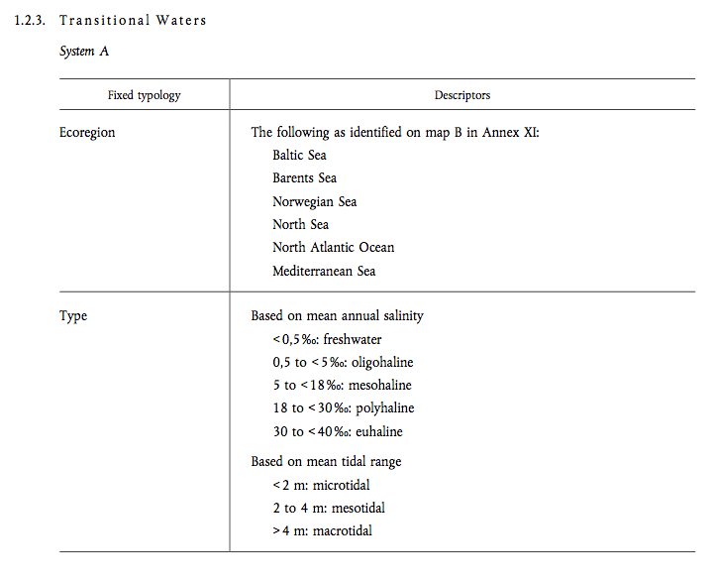

Annex V
Ontological elements for the classification of water status
Status definitions (high, good, moderate)
Monitoring frequency
Color codes

Annex VIII
Ontological elements for list of main pollutants

Article IX
Limit values and quality objectives
The Mercury Discharges Directive (82/176/EEC) (1);
The Cadmium Discharges Directive (83/513/EEC) (2);
The Mercury Directive (84/156/EEC) (3);
The Hexachlorocyclohexane Discharges Directive (84/491/EEC) (4); and
The Dangerous Substance Discharges Directive (86/280/EEC) (5).

Directive 2008/105/EC repeals Directives 82/176/EEC, 83/513/EEC, 84/156/EEC, 84/491/EEC and 86/280/EEC with effect from 22 December 2012.

2008/105/EC

Article 1

This Directive lays down environmental quality standards (EQS) for priority substances and certain other pollutants as provided for in Article 16 of Directive 2000/60/EC, with the aim of achieving good surface water chemical status and in accordance with the provisions and objectives of Article 4 of that Directive.

Article 4

1. Member States may designate mixing zones adjacent to points of discharge. Concentrations of one or more substances listed in Part A of Annex I may exceed the relevant EQS within such mixing zones if they do not affect the compliance of the rest of the body of surface water with those standards.
3. Member States that designate mixing zones shall ensure that the extent of any such zone is:
(a) restricted to the proximity of the point of discharge;
(b) proportionate, having regard to the concentrations of pollutants at the point of discharge and to the conditions on emissions of pollutants contained in the prior regu lations, such as authorisations and/or permits, referred to in Article 11(3)(g) of Directive 2000/60/EC and any other relevant Community law, in accordance with the application of best available techniques and Article 10 of Directive 2000/60/EC, in particular after those prior regulations are reviewed.

Article 6
1. A Member State shall not be in breach of its obligations under this Directive as a result of the exceedance of an EQS if it can demonstrate that:
(a) the exceedance was due to a source of pollution outside its national jurisdiction;
(b) it was unable as a result of such transboundary pollution to take effective measures to comply with the relevant EQS; and
(c) it had applied the coordination mechanisms set out in Article 3 of Directive 2000/60/EC and, as appropriate, taken advantage of the provisions of Article 4(4), (5) and (6) of that Directive for those water bodies affected by transboundary pollution.

Annexes
- 1: ENVIRONMENTAL QUALITY STANDARDS FOR PRIORITY SUBSTANCES AND CERTAIN OTHER POLLUTANTS
- 2: LIST OF PRIORITY SUBSTANCES IN THE FIELD OF WATER POLICY
- 3: SUBSTANCES SUBJECT TO REVIEW FOR POSSIBLE IDENTIFICATION AS PRIORITY SUBSTANCES OR PRIORITY HAZARDOUS SUBSTANCES

Given that it is not possible in practice to construct collecting systems and treatment plants in a way such that all waste water can be treated during situations such as unusually heavy rainfall, Member States shall decide on measures to limit pollution from storm water overflows. Such measures could be based on dilution rates or capacity in relation to dry weather flow, or could specify a certain acceptable number of overflows per year.

